FINAL YEAR PROJECT [MNC-401]

Prediction of Longwall Periodic Weighing and Local Fall interval

BY

1. Aditya Kumar Choudhary 21JE0050
2. Rahul Kumar Sharma

20JE0749

B.Tech (Mining Engineering)

Department of Mining Engineering

Indian Institute of Technology (Indian School of Mines)

Dhanbad-826004

Under the guidance of **Dr. Dondapati Gopi Krishna**,

Department of Mining Engineering

Indian Institute of Technology (Indian School of Mines)

Dhanbad-826004

ABSTRACT

Longwall mining is a widely adopted underground coal extraction method known for its high productivity. However, it is also associated with significant ground control challenges, particularly local roof falls, Main roof fall and periodic weighting. These events, caused by complex stress redistribution and strata behaviour ahead and above the longwall face, pose serious threats to miner safety, equipment integrity, and uninterrupted production. Accurate and timely prediction of such events remains a critical issue in underground mining operations.

This project focuses on analyzing historical field data from longwall operations to investigate the spatial and temporal characteristics of support pressure behaviour and its relationship with periodic weighting and roof fall occurrences. Unlike typical studies that aim to build predictive models, this work employs machine learning exclusively as an analytical tool—to extract patterns, identify high-risk zones, and visualize critical support behaviours—without developing or deploying predictive algorithms.

The data collected from the field underwent extensive preprocessing, including handling of missing values, normalization, and temporal alignment to allow meaningful comparisons across different face locations and time periods. Once the data was cleaned and prepared, it was subjected to a variety of analytical methods, including clustering, correlation analysis, and dimensionality reduction. Visualization techniques such as heatmaps and mean load density plots were used to graphically represent changes in support pressure along the face and over time. These visual tools proved highly effective in identifying high-stress zones and understanding how load builds up before a weighting event or a local roof fall. The heatmaps revealed clusters of elevated support pressure that persisted across several meters of face advance, aligning closely with areas where past roof instability had been reported. Meanwhile, the analysis of mean load density trends showed a cyclical pattern consistent with known periodic weighing behaviour, with pressure peaks occurring just before a drop that typically signalled roof caving or stress relief.

By utilizing machine learning for data interpretation and visualization, this project provides deep insights into the mechanisms underlying roof behaviour in longwall mining. The outcomes contribute to better planning and decision-making in support system design and operational scheduling. Furthermore, this analytical framework lays the groundwork for future research focused on developing real-time early warning systems, where predictive modelling could later be incorporated for proactive hazard mitigation.

CHAPTER -1 INTRODUCTION

Longwall mining, a method that uses machines to extract coal underground, has shown its ability to get the most out of resources while keeping workers safer at the coal face. This way of mining takes out a long stretch of coal, which lets the rock above fall in behind the miners as they move back. While this planned caving helps make the process work well, it also brings big ground control issues. The main problems are keeping the roof from falling and predicting sudden changes in how the rock layers act. These issues show up as times when the weight above shifts onto the powered supports in cycles, and as local roof falls. These falls can happen without warning because of weak spots in the roof rock or changes in mining conditions. Both put workers at risk and can stop work, cause delays, and make mining more expensive.

Grasping and controlling how the roof interacts with powered supports plays a key role in keeping operations safe and productive. As mining moves forward and the goaf grows behind the face, the rock above starts to sink and shift its weight to nearby unextracted coal and support systems. This leads to regular changes in the load on powered shields, a process we call periodic weighing. Small roof collapses can happen too often in specific spots, due to weak roof rock types, cracked rock masses, or supports that don't react well enough. These are just as dangerous. Predicting when and where these events will occur has been a tough problem in longwall mining for a long time.

In summary, longwall mining operations should struggle with underlying risks related to roof stability and unexpected start behaviour. While traditional methods provide real-time monitoring, they decrease in extracting deep insight into the cause-effects relationship within the mining environment. Using machine learning as a data analysis tool, this study increases understanding of periodic weight and local decline, which introduces a foundation for future forecasting applications, supporting current operating reforms in ground control strategies.

* 1. **Objectives:**

The primary goal of this project is to predict the local fall and periodic weighing intervals based on specific geo-mining conditions. The application of machine learning aims to address the following objectives:

1. **Improve Operational Safety**: By forecasting roof weighing and fall intervals, workers can take preventive measures, minimizing exposure to unexpected roof collapses or excessive load conditions.
2. **Enhance Productivity**: Predictive insights allow for better scheduling and proactive adjustments to support structures, reducing downtime and allowing for uninterrupted mining operations.
3. **Optimize Resource Use**: By accurately predicting roof conditions, resources such as time, labour, and equipment can be better allocated, ensuring that mining operations remain cost-effective

**1.2 Scope:**

This project focuses on analyzing shield pressure data and roof fall records from longwall mining operations using machine learning-based visualization tools. The scope includes generating heatmaps, time-series plots, and correlation graphs to identify patterns related to periodic weighting and local roof falls

Machine learning (ML) techniques are employed for visual analysis through heatmaps, time-series plots, and correlation matrices. This project aims to:

* Visualize spatial and temporal variations in power support pressure.
* Identify patterns linked to periodic weighting and local fall events.
* Support decision-making on support layout and mining sequences.
* Explore the potential for enhancing automation and early warning systems

CHAPTER 2 LITRATURE REVIEW

**2.1 Introduction to Longwall Mining**

Longwall mining is a high-production underground coal extraction technique widely adopted for its efficiency and safety in extracting deep-seated and thick coal seams. The method involves the full extraction of large coal panels using a shearer that moves along the face, supported by a series of hydraulic powered supports or shields. As the face advances, the roof behind the shields collapses in a controlled manner into the void space known as the goaf. This mechanised retreat method enables continuous production and high output per unit area, making it particularly suitable for large-scale underground mining.

Despite its mechanisation, longwall mining is highly sensitive to geological and geomechanical conditions. The immediate roof (thin laminated layers) and the main roof (thicker and stronger strata like sandstone) interact dynamically with the shield supports. One of the most critical and recurring challenges is the phenomenon of periodic roof weighting—a condition where shield supports experience sudden, cyclic increases in load due to delayed collapse or bridging of roof strata. Additionally, local roof falls, particularly under weak or fractured main roofs, can occur in front of the shield canopy, posing safety risks and disrupting production.

The Adriyala Longwall Project (ALP), India’s first high-capacity mechanised longwall mine operated by SCCL, presents a compelling case study in this regard. Field studies on Panels No.1 and No.2 show that while Panel No.1 encountered a competent main roof with predictable periodic weighting intervals, Panel No.2 was affected by a fractured, cavity-prone roof leading to irregular loading behaviour and operational difficulties. Real-time shield pressure monitoring data from over 4500 m of face advancement revealed distinctive shield pressure trends and roof interaction patterns across the two panels​.

To monitor and analyse these strata behaviours, powered support pressure data (e.g., setting pressure, final pressure, and Time Weighted Average Pressure or TWAP) and shearer location data are critical. In ALP, leg pressures from 146 shields were continuously recorded, offering high-resolution datasets to study mining cycles and identify conditions leading to excessive loading or roof instability. These datasets are often too large and complex for traditional manual or static analysis methods.

In this context, Machine Learning (ML) plays a valuable analytical role—not necessarily for prediction or automation, but for extracting actionable insights from real-time sensor data. In this project, ML is applied to generate heatmaps of powered support pressure versus face advance and graphs of mean load density, which help visualise load concentration zones, assess shield performance trends, and understand face-wise pressure distribution. These graphical and spatial representations allow mine operators and engineers to detect abnormal loading patterns, identify high-risk zones, and make informed decisions regarding shield maintenance or roof control strategies.

Thus, while ML is not used here for real-time predictive modelling, it serves as a powerful tool for post hoc analysis and visualisation—enhancing the interpretability of complex shield pressure datasets and contributing to more effective strata control and equipment management in longwall mining.

**2.2 Longwall Mining in India**

India, endowed with vast reserves of thermal coal, has long recognised the need to mechanise underground mining to meet growing energy demands. While opencast mining has dominated the Indian coal sector due to its lower cost and simplicity, the increasing depth of coal seams and land-use constraints have made underground mechanisation imperative. In this context, longwall mining has emerged as a key technology for enhancing underground coal production with improved safety and productivity.

**2.2.1 Historical Development**

Longwall mining in India began in the 1970s with pilot projects initiated by Coal India Limited (CIL) and Singareni Collieries Company Limited (SCCL). Early projects included Moonidih Colliery in Jharkhand and Kottadih and Churcha collieries in West Bengal and Chhattisgarh, respectively. However, these initial attempts faced significant challenges such as inadequate strata control, lack of skilled manpower, poor equipment availability, and insufficient understanding of powered support and strata interaction. Many of these projects were ultimately discontinued or underperformed due to frequent face collapses and unmanageable delays (Ghose et al., 2003; Sarkar, 1998).

**2.2.2 Technological Advancements and Modern Projects**

Over the years, Indian longwall mining technology has evolved, benefiting from global partnerships and improvements in shield support systems, shearers, conveyors, and real-time monitoring tools. A significant breakthrough was achieved with the commissioning of the Adriyala Longwall Project (ALP) in 2014 by SCCL in the Ramagundam coal belt of Telangana. This was India’s first high-capacity longwall system, with a rated production capacity of 3 million tonnes per annum (MTPA), state-of-the-art 2x1152-tonne powered roof supports, and a Double-Ended Ranging Drum (DERD) shearer​.

ALP has successfully demonstrated that modern longwall systems can deliver high productivity in Indian conditions, provided that the geological conditions are well understood, and appropriate strata control measures are in place. However, operational experience from its two panels—Panel No.1 and Panel No.2—also highlighted the critical role of roof competency. Panel No.1, with a strong, massive sandstone roof, showed regular periodic weighting patterns and minimal equipment failures. In contrast, Panel No.2, affected by a weak and fractured main roof, faced cavity formation, local roof falls, increased downtime, and significant shield breakdowns​.

**2.2.3 Current Status and Limitations**

As of today, only a limited number of Indian mines operate longwall faces successfully, primarily due to high capital costs, complex logistics, and challenging geology. Other limitations include:

* **Inadequate strata monitoring**: Real-time pressure monitoring is still not widely adopted or integrated with predictive tools.
* **Shortage of skilled personnel**: Longwall mining requires a higher level of training and operational discipline.
* **Supply chain issues**: Delays in spare part availability and dependency on OEMs affect equipment utilisation.
* **Strata control issues**: Indian coalfields often present unpredictable roof conditions, including weak or multi-seam interactions.

**2.2.4 The Way Forward**

To expand the scope of longwall mining in India, future operations must incorporate data-driven decision-making tools and robust real-time monitoring. The application of Machine Learning (ML) techniques, such as those used in this project for visualising shield pressure behaviour through heatmaps and mean load density trends, offers a promising direction for strata management, equipment maintenance planning, and safety enhancement.

With continued advancements and integration of digital technologies, longwall mining in India holds the potential to transform underground coal production and reduce the sector’s reliance on opencast mining.

**2.3 Brief on Moonidih Longwall**

The Moonidih Colliery, operated by Bharat Coking Coal Ltd (BCCL) in Dhanbad, Jharkhand, was the site of India’s first mechanised longwall mining operation, introduced in 1978. Located in the central part of the Jharia Coalfield, the mine possesses approximately 1240 million tonnes of geological reserves. It is classified as a Degree III gassy mine as per the Indian Coal Mines Regulations (1957), with gas content ranging from 6 m³/t to 15 m³/t. The mine hosts 20 coal seams, and the longwall panels operate at depths of 300 to 700 meters, with seam gradients ranging from 1 in 6 to 1 in 7. Seam thicknesses suitable for longwall deployment vary between 2 to 5 meters.

The longwall equipment installed at Moonidih has a targeted production capacity of 2.5 Mtpa of coking coal. The overlying strata are primarily composed of sandstone and coal, ranging from 9 to 90 meters in thickness and are generally moderately cavable. The method of extraction is longwall retreating with caving, leveraging the laminated nature of the immediate roof beds, which tend to separate easily despite the presence of strong main roof strata with compressive strengths up to 120 MPa. Scientific studies in the mine have identified the main fall span to vary between 35 and 55 meters, corroborated with field observations​.

**2.3 Brief on Jhanjra Longwall**

The Jhanjra Colliery, under Eastern Coalfields Limited (ECL) in West Bengal, is located in the Raniganj Coalfield. Spanning around 11.5 sq. km, this block is structurally complex, featuring multiple faults with throws ranging from 15 to 110 meters. It comprises eight coal seams with total reserves estimated at 200 million tonnes.

Longwall mining was initiated in the R-VI seam in 2016, with a panel length of 1652 meters and a face width of 145 meters. The seam thickness ranges from 4.5 to 5.5 meters, and the depth of cover is between 160 and 170 meters. The parting between the R-VI and the overlying R-VIIA seam is approximately 75 meters, and the seam gradient is 1 in 16. The mine is categorized as a Degree I gassy operation. Despite the faulting, the strata at Jhanjra have been reported to cave regularly, contributing to the operational stability of the longwall system​.

**2.4 Brief on Adriyala Longwall Project**

The Adriyala Longwall Project (ALP) is located in the Godavari Valley Coalfield (GVCF) of Telangana, which spans approximately 17,000 sq. km and accounts for nearly 27% of India’s coal basin area. ALP falls within the Ramagundam area of the Peddapalli district, which has been a hub of coal mining activity since 1957.

ALP is a pioneering venture by Singareni Collieries Company Limited (SCCL), marking India’s first high-capacity longwall project with a target production of 3.0 MTPA. The project hosts seven seams (IA, I, II, IIIA, IIIB, III, and IV), out of which the I, II, III, and IV seams have workable thicknesses. Longwall mining is currently being carried out in the I-seam, which has a thickness ranging from 5.5 to 7.3 meters and contains two clay bands. The roof comprises massive sandstone layers with thicknesses between 20 to 26 meters, and the Rock Mass Rating (RMR) of the roof strata is reported as 46 before and 22.4 after extraction. The stone roof has an RMR of 56​.

Technologically, the project utilises 146 powered supports of 2-legged lemniscate design, each with a 1152-tonne capacity, and a Single-Ended Ranging Drum (SERD) EL3000 shearer with an installed power of 2245 kW. The gate roads are driven with a coal roof, while trunk roads are developed in the stone roof section. Longwall Panels No.1 and No.2 have been successfully extracted, and Panel No.3 is currently under operation​.

**2.5 Longwall Mining and Its Challenges**

Longwall mining is a fully mechanized underground coal extraction method known for its high efficiency, safety, and productivity. The technique involves retreating a shearer along a longwall face—typically 100 to 400 meters wide and up to several kilometres, in length—while hydraulic powered supports (shields) hold up the roof immediately behind the working face. As the face advances, the roof behind the shields is allowed to collapse into the goaf in a controlled manner. This method is especially suitable for thick, uniform, and gently dipping coal seams.

The success of a longwall operation hinges on the predictable behaviour of overlying strata and the performance of support systems. However, in practice, several geotechnical and operational challenges can compromise the efficiency and safety of longwall mining.

**2.2.1 Geotechnical Challenges**

One of the most significant geotechnical concerns in longwall mining is the stability of the immediate and main roofs. The immediate roof consists of weaker, laminated strata and governs short-term face stability. The main roof, typically composed of thicker and stronger rocks like sandstone, controls long-term strata behaviour. The failure or delayed collapse of the main roof can result in a phenomenon known as periodic roof weighting, where the load on powered supports suddenly increases in cycles. If the roof remains suspended over a large span, it can collapse violently, placing extreme stress on supports and increasing the risk of equipment failure or face closure​.

Another frequent hazard is local roof falls, especially in fractured or cavity-prone roof strata. These sudden collapses may occur in front of or adjacent to the shields and are often unpredictable. They obstruct the face conveyor and shearer movement, leading to significant production downtime and posing safety hazards to personnel.

**2.2.2 Operational and Equipment-Related Challenges**

Even with high-capacity powered supports (e.g., up to 1152 tonnes per shield as in the Adriyala Longwall Project), roof collapses and periodic weighting can lead to mechanical failures and increased wear. In Panel No.2 of ALP, for example, fractured main roof strata led to erratic loading, severe cavity formation, and frequent breakdowns of hydraulic systems and support components. In contrast, Panel No.1 with a competent roof showed more stable pressure trends and reduced maintenance requirements​.

Sensor noise, hydraulic leaks, and intermittent data acquisition further complicate the monitoring of shield performance. The inability to reliably detect mining cycles and pressure anomalies in real-time can delay preventive maintenance and increase the risk of sudden failures.

**2.2.3 Data and Monitoring Limitations**

Longwall faces are instrumented with real-time pressure monitoring systems that collect data from multiple shield legs. However, large volumes of sensor data (such as pressure vs. time plots for hundreds of shields over thousands of mining cycles) are difficult to interpret without advanced analytical tools. Conventional empirical or numerical approaches are often insufficient to handle such complex datasets, especially in real time.

**2.2.4 Need for Advanced Analysis**

To address these challenges, the use of analytical tools like Machine Learning (ML) has gained attention. While not used for automation in this study, ML serves as a data analysis tool to generate heatmaps and pressure distribution graphs across the face. These visualisations help mine planners identify abnormal pressure zones, understand shield performance, and correlate load patterns with roof behaviour. Such insights are essential for optimising maintenance, improving safety, and guiding future operational decisions.

**2.5 Deformation and Loading Behaviour of Immediate Roof and Main Roof**

The deformation and loading behaviour of the immediate and main roof strata during longwall mining significantly influences face stability, equipment performance, and strata management strategies. The roof strata are broadly classified into two distinct geological layers:

* The **immediate roof**, which lies directly above the coal seam and typically comprises weak, laminated materials.
* 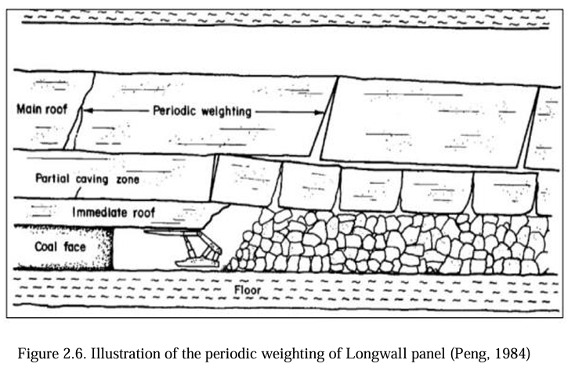The **main roof**, composed of stronger, more competent strata like sandstone, that span larger distances before collapsing.

Figure 1:Illustration of the periodic weighting of Longwall panel (Peng, 1984)

**2.5.1 Immediate Roof Behaviour**

The immediate roof usually caves soon after the shield support advances. In the Adriyala Longwall Project (ALP), the I Seam's immediate roof includes two clay bands (0.15 m to 0.9 m thick) with uniaxial compressive strength (UCS) values as low as 2 MPa. Due to their weak nature, these strata fail early, resulting in fragmented collapse behind the shields. However, under certain conditions—particularly in Panel No.2—the immediate roof was observed to collapse prematurely in front of the shield, leading to cavity formation and spalling of the roof at the face line​.

Such premature failure reduces the effectiveness of shield support and shifts abutment stress toward the face. As a result, high-pressure zones form in front of the shields, increasing the risk of boulder falls into the canopy or the Armoured Face Conveyor (AFC). These local falls compromise production and pose significant safety hazards​.

**2.5.2 Main Roof Behaviour**

The main roof acts as a cantilever beam over the shield-supported area. It does not collapse immediately after extraction but spans a certain distance until its tensile strength is exceeded. This results in a sudden, often violent collapse referred to as main roof weighting. The first major roof collapse occurs at a distance termed the main fall span (lp) from the start line of the panel, and subsequent collapses occur at intervals called the periodic weighting interval (ls)​.

The behaviour of the main roof is determined by several factors, including:

* Thickness and strength of the rock layer
* Elastic properties (modulus, tensile strength)
* Mining geometry and face advance rate

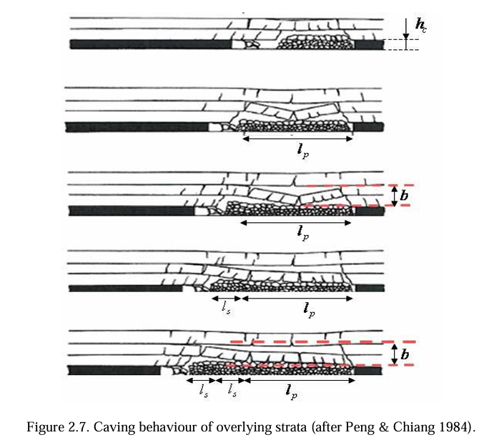In ALP, the I Seam’s main roof comprises three sandstone beds: 21 m, 5 m, and 9 m thick, separated by a 6 m thick coal-clay parting. The complex stratification causes variable collapse behaviour, sometimes leading to multiple or delayed roof falls. The bed separation occurring between roof layers further influences the loading conditions on shields​.

Figure 2: Caving behaviour of overlying strata (after Peng & Chiang 1984).

**2.5.3 Shield Pressure Response During Weighting**

As the main roof collapses cyclically, shield supports experience sharp pressure increases, especially during periodic weighting events. The leg pressure on the shields rises due to the sudden transfer of roof load. These pressure peaks, if not managed, can lead to shield leg failure or excessive convergence.

To quantify shield performance, parameters like:

* **Final Pressure**
* **Setting Pressure**
* **Time Weighted Average Pressure (TWAP)**

are monitored using real-time data acquisition systems. These parameters, particularly TWAP, are indicative of the overall stress exposure on the shields across mining cycles. Panel-wise differences in TWAP and pressure trends reflect changes in roof competency and caving patterns​.

**2.5.4 Maximum Caving Height**

Maximum caving height in longwall mining refers to the vertical extent to which the overlying strata collapse and fill the void created by coal extraction. Understanding and estimating this parameter is crucial for evaluating the stress redistribution, goaf stability, and the load-bearing requirement of longwall supports.

The caving height depends on several factors including the extraction height and the bulking factor of the caved material. The bulking factor is a measure of the volume increase of rock mass upon fragmentation. A simplified formula used to estimate the maximum caving height Hc is:

Where:

* he is the extraction height,
* k is the bulking factor.

**Practical Implications**

* A higher caving height leads to more effective stress relief but may require stronger shields.
* Inadequate caving results in hanging main roofs, increasing the risk of periodic weighting and sudden collapse events.

**2.6 Periodic Roof Weighting**

Periodic roof weighting is a recurring phenomenon in longwall mining where roof strata exert high loads on hydraulic shield supports at regular intervals. These weightings occur due to the cyclical failure of overhanging roof layers as the longwall face advances. They are characterized by two main parameters: weighting interval and intensity.

The weighting interval refers to the distance between two successive roof collapses, while intensity relates to the peak pressure exerted on the shield during each event. These parameters depend largely on the nature of the immediate and main roof strata. Typically:

* Immediate roofs are weaker and fall quickly behind the shields.
* Main roofs are stronger and tend to overhang, acting like cantilever beams.

As the overhang increases, it eventually reaches a critical span where it can no longer sustain its own weight and collapses, causing a sharp spike in shield pressure. This is observed in controlled weighting conditions. However, in uncontrolled periodic weighting, the roof may break in front of the shields, leading to sudden and extremely high pressure on the supports, posing a safety risk.

In the Adriyala Longwall Project (ALP), multiple periodic roof weighting events were observed, with an average interval of 15 to 20 meters. Pressure plots showed that during these intervals, final shield pressures peaked significantly, especially in areas with thick or weak main roof strata​.

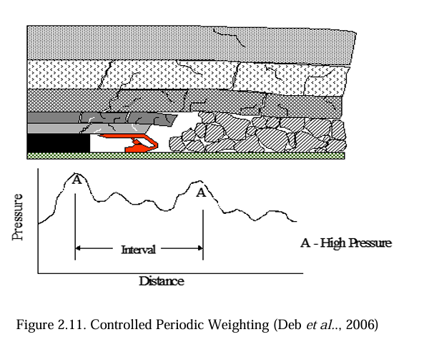These patterns are essential for understanding roof behavior and optimizing shield design and mining operations. Monitoring such events allows for better prediction and control of roof loading, reducing the risk of operational delays or hazardous conditions.

Figure 3:Controlled Periodic Weighting (Deb et al.., 2006)

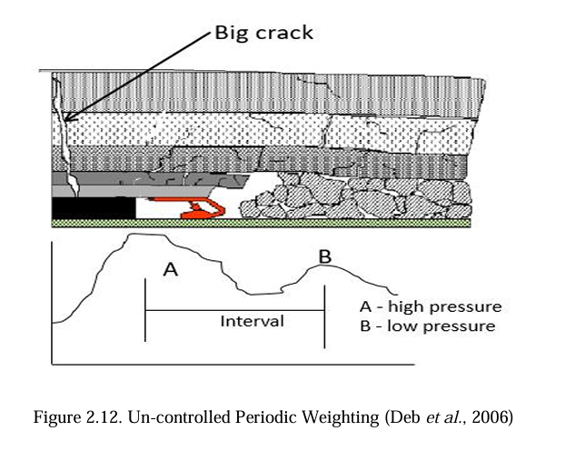

Figure 4:Un-controlled Periodic Weighting (Deb et al., 2006)

CHAPTER-3

METHODOLOGY

**3.1 Data Collection**

The data for this study was collected from a Jhanjra longwall mining. Shield pressure data was obtained from the hydraulic legs of powered roof supports, recorded continuously during face advancement. Detail of the mines is in the Table 1 and Table 2.

Table 1: Geo-mining parameters of the Longwall Panel-8

|  |  |
| --- | --- |
| Name of the Mine | Jhanjra Project Colliery |
| Name of the Seam | Seam R-VI |
| Name of the Panel | Longwall Panel-8 |
| Length of the face | 145 m (centre to centre) |
| Length of the Panel | 650 m |
| Depth of the Seam | Max – 203.60 & Min – 175.00 m |
| Seam Thickness | 5.24 m (Average) |
| Height of extraction | Full height of the seam |
| Gradient of the Seam | 1 in 16 |
| Degree of gassiness | Degree I |
| Nature of the immediate roof | Sandstone |
| Nature of immediate floor | Sandstone |

Table 2:Support parameters

|  |  |
| --- | --- |
| Capacity & Type | 2 X 1100 T |
| Number of Shields | 84 |
| Yield pressure | 43.8 MPa |
| Setting Pressure | 28 MPa |
| Canopy Length | 4.10 m (Normal PRS)/ 4.25 m (End PRS) |
| Open Height | 5.60 m |
| Closed height | 2.60 m |
| Web depth | 0.80 m |

**3.2 Data processing**

The shield pressure data obtained from the hydraulic supports consisted of readings from both the dip and rise legs of each shield. To streamline the analysis, the first step involved calculating the average pressure between the dip and rise legs for each shield at every recorded timestamp. This gave a single representative value that reflected the total load acting on each shield unit, simplifying the data while preserving its accuracy.

Following this, the data was organized shift-wise (typically three shifts per day). For each shield, the average pressure recorded during a shift was computed, resulting in a mean shift pressure for every operational period. These shift-wise values were then used to calculate the average daily pressure for each shield by taking the mean of all shifts within a 24-hour period. This daily aggregation allowed for easier detection of long-term pressure trends and comparison across different days of operation.

Once the daily average shield pressures were established, the Mean Load Density was calculated. This is defined as the average load per unit area experienced by each shield and is a key indicator of the stress distribution from the roof to the support system. The mean load density was derived by dividing the average shield pressure by the effective support area of the shield canopy. This parameter enabled better understanding of the loading behaviour across the face and provided insights into variations in stress concentration, which are often associated with roof fall risk zones or periodic roof weighting events.

This multi-step processing ensured that the data was clean, representative, and suitable for further visualization and analysis, laying a solid foundation for interpreting longwall roof behaviour using machine learning-based tools.

**3.3 Data Analysis**

After preprocessing, the cleaned data was subjected to visual and statistical analysis. Heatmaps were generated to display shield pressure distributions across the longwall face, helping to identify zones under high stress. Time-series plots were used to observe patterns of periodic roof weighting and pressure fluctuations. Key parameters such as. Correlation analysis was conducted to link pressure peaks with observed roof fall incidents. All visualizations and analyses were carried out using Python libraries including Matplotlib, and Seaborn, on pattern identification rather than predictive modelling.

CHAPTER-4

RESULT AND DISCUSSIONS

**4.1 Interpretations of Results**

During a main fall, the significant increase in load experienced at the coal face is referred to as main weighting. It was observed that the central portion of the longwall face typically experienced greater loading compared to the gate end regions. This can be attributed to the natural bending behavior of the overlying strata along the length of the face, which tends to be more pronounced at the centre during such collapses. As a result, the shields in the middle section of the face are subjected to higher pressures. Referring to the corresponding figure (Fig. b), the front abutment stress distribution along the face length illustrates this phenomenon clearly. Under progressing mining conditions, both the T-junction at the gate ends and the central segment of the longwall face are frequently exposed to maximum stress zones, highlighting the need for enhanced support and monitoring in these critical areas.

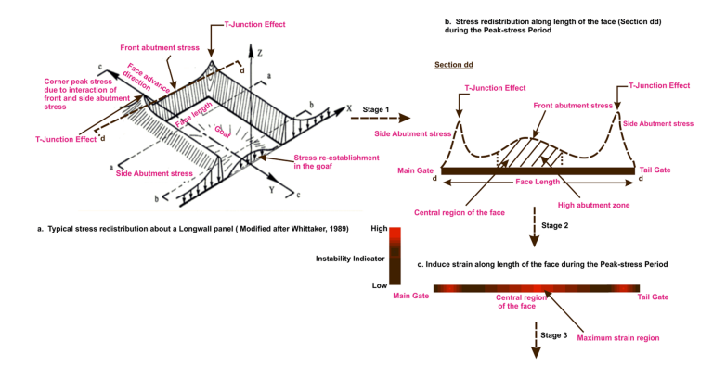

Figure 5:Stress distribution along the face.

Due to the distribution of the front abutment stress along the face, the powered supports along the longwall face are typically categorized into three zones: maingate zone (PS-1 to PS-20), mid zone (PS-21 to PS-64), and tailgate zone (PS-65 to PS-84). Each of the 84 powered supports (PS) was equipped with two leg circuits, totalling 168 hydraulic leg circuits, with each leg monitored by a dedicated pressure gauge. This setup enabled detailed monitoring of pressure variations and facilitated the calculation of Mean Load Density (MLD), a key indicator of strata behavior and weighting activity along the face.

**4.1 Heatmap Analysis**

To visualize the spatial behavior of pressure variations, heatmaps were constructed and presented in Figures 6, 7, and 8. These plots mapped pressure intensity across the shield numbers (vertical axis) and face progress (horizontal axis), revealing clear patterns of periodic weighting. Red and dark yellow zones indicated areas of elevated pressure, which correspond to the occurrence of periodic weighting events. Notably, these heatmaps demonstrated that periodic weighting predominantly occurred in the middle section of the panel, suggesting that this zone absorbed the majority of strata movements during mining.

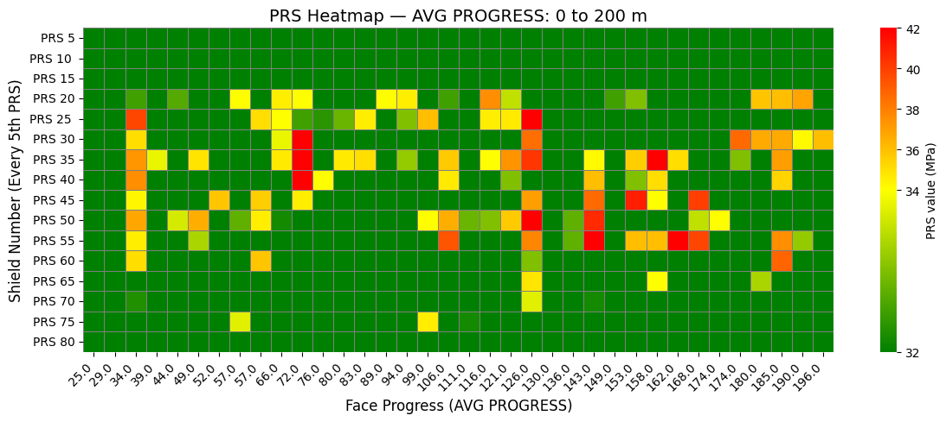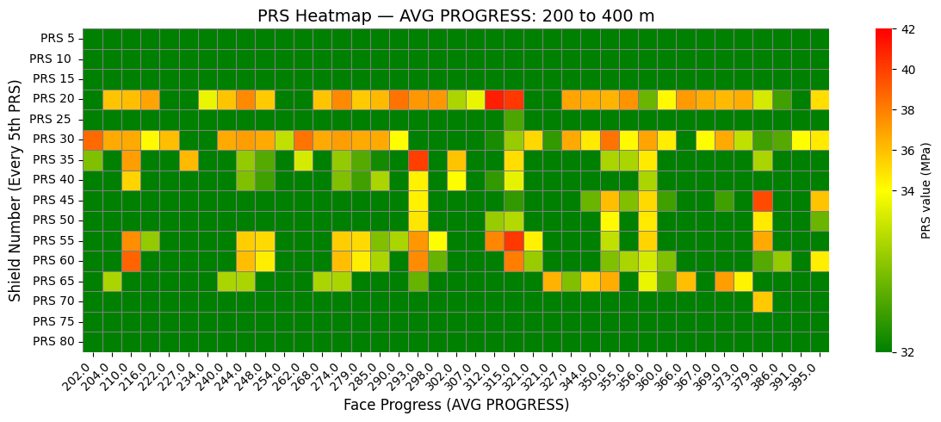Furthermore, the heatmaps showed that barrier (chain) pillars located on the sides of the panel did not exhibit signs of yielding or failure, even when the face approached them. This implies that these structural elements were effective in transferring and resisting additional load, maintaining their integrity and serving their intended function of confining the excavation zone.

Figure 6:Pressure heat map for face progress of 0-200 meter

Figure 7:Pressure heat map for face progress of 200-400 meter

In order to visualise the periodic roof weighting phenomena in the study panel, the final pressures of each mining cycle of shields are plotted with distance from the setup room in Figures 6, 7, and 8 for face progress of 580 metre. The pressure plots are created using the average pressure values of 5 consecutive shields and colour ranges are decided based on the pressure values. The vertical axis signifies the width of the panel from MG to TG (PRS- 1 to PRS-84) by grouping them as five consecutive shields. Each coloured box in the figure represents the pressure range during the advancement of the longwall face.The figure 6, 7, and 8 shows a periodic roof weighting zone marked by ovals indicate localised high-pressure zones.

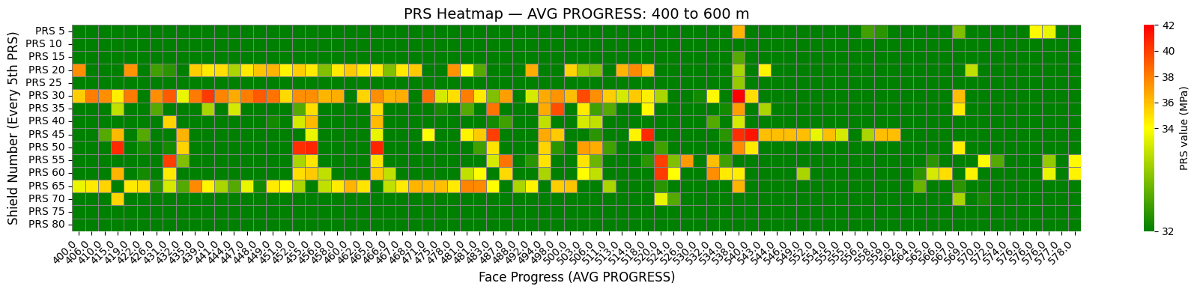

Figure 8: Pressure heat map for face progress of 400-600 meter

**4.2 Mean Load Density Distribution**

Figure 9,10, and 11 illustrates the variation in Mean Load Density (MLD) for the mid zone. MLD, calculated from the hydraulic leg circuit pressures, provides a quantitative measure of the load borne by the supports. As shown in the figure, the mid zone largely experienced normal strata pressure, attributed to the absence of overlying barrier pillars in this section of the overlying seam.

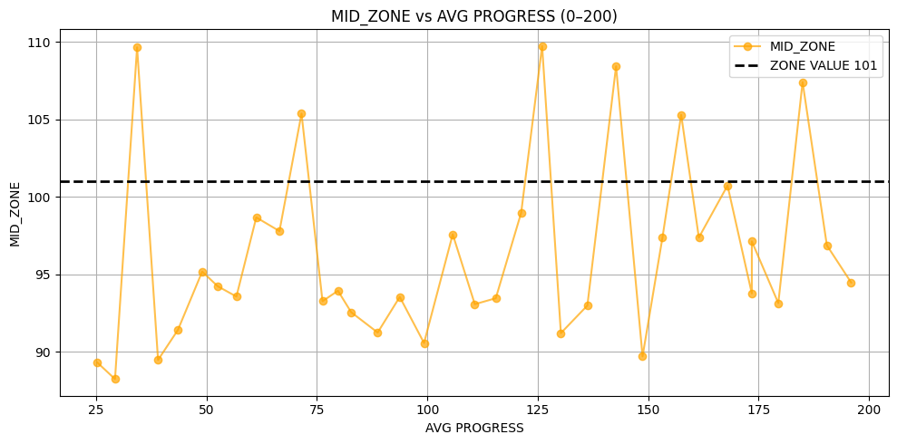

Figure 9:Variation of MLD for mid zones with face progress of 0-200 meter

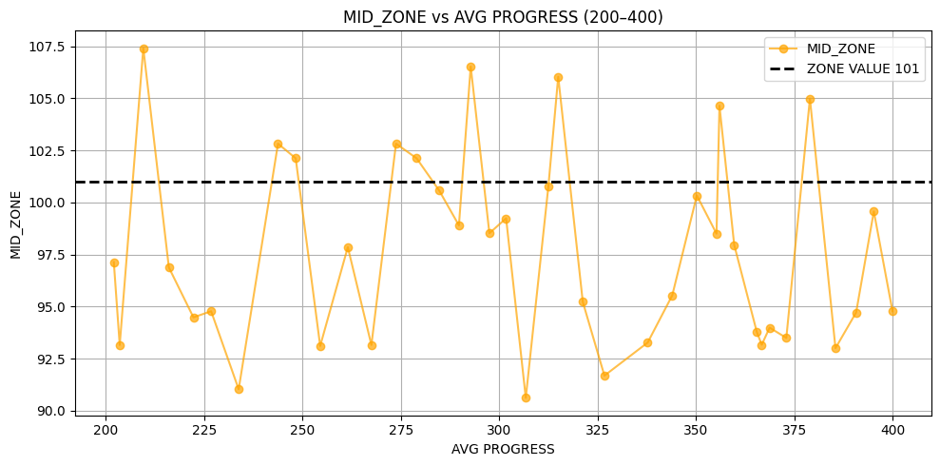

Figure 10:Variation of MLD for mid zones with face progress of 200-400 meter

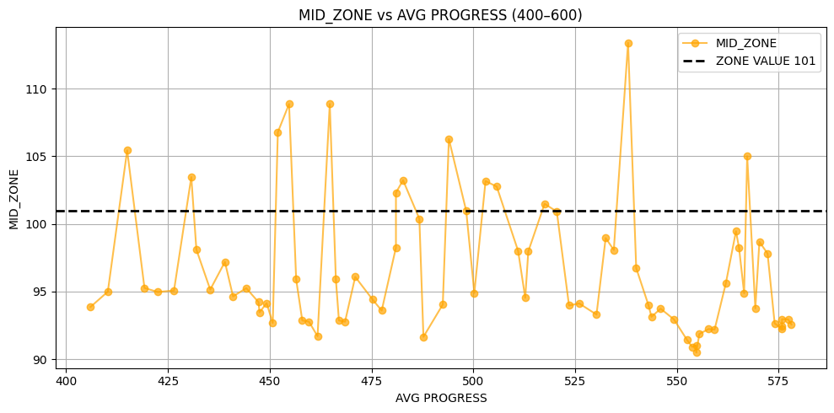

Figure 11:Variation of MLD for mid zones with face progress of 400-600 meter

**4.3 Interpretations of Result**

The analysis of the processed shield pressure data through heatmaps and line graphs revealed clear patterns corresponding to periodic roof weighting and mainfall events. The heatmaps, generated from the average daily shield pressures, visually highlighted high-pressure zones along the longwall face. These zones, marked by a sudden and intense increase in pressure across multiple shields, indicated the occurrence of main roof falls (mainfall) and periodic weighting. Such events were typically observed at regular intervals along the face advance, validating the presence of cyclical roof loading behaviour.

Table 3:Periodic weighting intervals during extraction of the panel

|  |  |  |
| --- | --- | --- |
| **FACE PROGRESS (m)** | **Fall Number** | **Weighing Interval (m)** |
| 34 | LF-1 | _ |
| 72 | LF-2 | _ |
| 126 | MF | 54 |
| 143 | PF-1 | 17 |
| 158 | PF-2 | 15 |
| 185 | PF-3 | 27 |
| 210 | PF-4 | 25 |
| 244 | PF-5 | 34 |
| 274 | PF-6 | 30 |
| 293 | PF-7 | 19 |
| 315 | PF-8 | 22 |
| 356 | PF-9 | 41 |
| 379 | PF-10 | 23 |
| 415 | PF-11 | 36 |
| 431 | PF-12 | 16 |
| 455 | PF-13 | 24 |
| 465 | PF-14 | 10 |
| 483 | PF-15 | 18 |
| 494 | PF-16 | 11 |
| 503 | PF-17 | 9 |
| 520 | PF-18 | 17 |
| 538 | PF-19 | 18 |
| 567 | PF-20 | 29 |

The details of the local falls, main fall and periodic falls occurred are tabulated below with respect to the face progress in Table 3. Periodic falls along with intervals are shown in Figure 5 and frequency distribution of periodic fall spans is shown in Figure 6. The most striking observation was the occurrence of mainfall at face progress of 126 meters, with a fall span of 54 meters the largest single span recorded in the dataset during the mainfall. This singular event suggests that mainfall is a rare but impactful incident, often resulting from prolonged stress accumulation.

On the other hand, Periodic Weighing were significantly more frequent, with 20 instances recorded across different stages of face progress. The first periodic fall occurs at face progress of 17 meter after the occurrence of mainfall. The average fall span for these periodic fall events was 22.05 meters, with a range from 9 to 41 meters, showing that while individual periodic weighing events are less severe than mainfall, they occur regularly and still result in meaningful displacement.

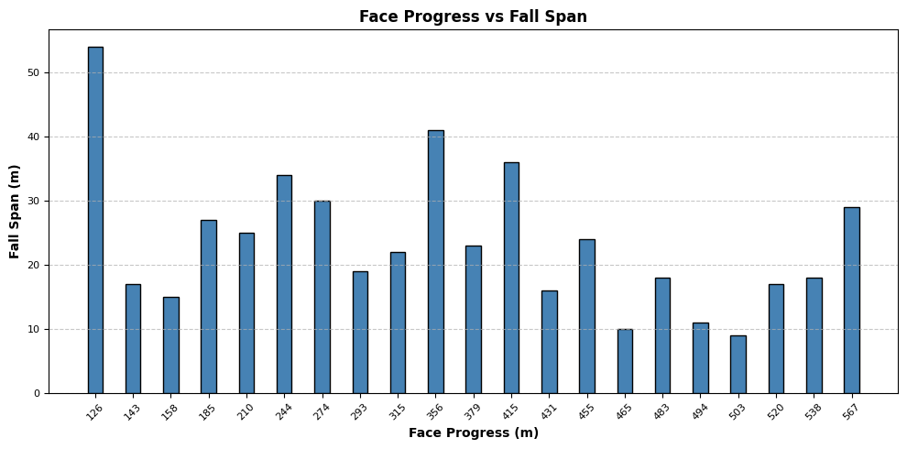

Figure 12:Periodic falls with face progress

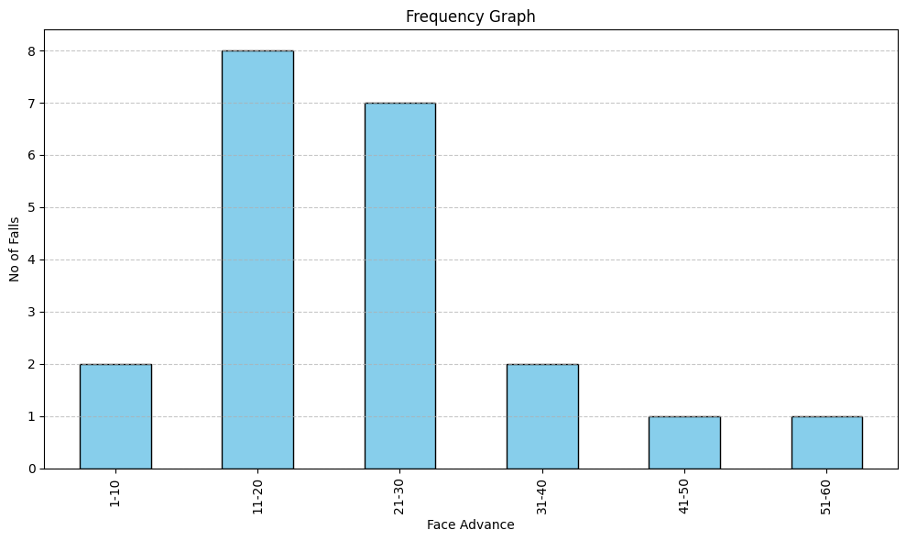

Figure 13:Frequency distribution of periodic fall span

**4.4 Summary**

The comprehensive analysis of MLD values, high-pressure events, and spatial pressure heatmaps reveals a cyclical pattern of stress accumulation and release across the longwall face. Periodic Weighing was observed to occur at consistent intervals and in specific face zones, especially in the mid panel region. This pattern supports the development of predictive tools for anticipating periodic weighing events based on real-time MLD trends and face advancement data. Importantly, early detection of rising MLD or abnormal shifts in pressure zones can enable timely interventions, potentially reducing the risk of Mainfall (MF) events

CONCLUSION

The comprehensive analysis of shield pressure data, Mean Load Density (MLD), and fall events along the longwall face has provided critical insights into the behavior of roof strata and the performance of powered supports during mining operations. By dividing the longwall face into three zones: tailgate zone, mid zone, and maingate zone and analyzing pressure variations using heatmaps and line graphs, the study successfully visualized the cyclical nature of roof loading, especially focusing on Periodic Weighing and Mainfall phenomena.

The heatmaps constructed from shield pressure readings effectively revealed spatial patterns of stress concentrations. Elevated pressure zones, shown in red and yellow shades, were prominently located in the middle section of the panel, indicating that this area experienced the most frequent and intense periodic roof weightings. These localized high-pressure zones corresponded to regular periodic weighing events and were consistently observed throughout the panel's advancement. The absence of yielding in barrier (chain) pillars further confirmed their structural effectiveness in supporting load transfer and maintaining excavation stability.

Pressure plots for individual mining cycles also highlighted the periodic roof weighting behavior, with average shield pressures grouped by five shields to capture localized pressure buildups. This method further validated the cyclical roof behavior, showing recurring pressure peaks as the face advanced. Additionally, MLD trends demonstrated that the mid-zone of the face generally experienced normal strata pressure, likely due to the absence of overlying barriers in this region, whereas occasional shifts in pressure zones to the top or bottom indicated localized disturbances in the overlying strata.

From the event data, the analysis identified a single mainfall at 126 meters of face progress with a span of 54 meters, marking the most significant and rare fall in the dataset, typically resulting from prolonged, unresolved stress. In contrast, 20 periodic fall events were recorded between 143 m and 567 m of face progress, with an average span of 22.05 meters, suggesting a regular but less severe mechanism of stress relief. These observations reinforce the role of periodic weighing as a predictable and manageable stress-release process, whereas mainfalls are rare but critical events requiring proactive stress monitoring.

In summary, this study demonstrates that through continuous monitoring of shield pressures and MLD, it is possible to predict and manage periodic weighting events, thereby reducing the likelihood of hazardous mainfalls. The clear spatial and temporal patterns observed in pressure variations and fall occurrences establish a foundation for predictive modelling and real-time monitoring strategies, aimed at improving operational safety and ground control in longwall mining.

REFERENCE

1. Chauhan, S., Agarwal, A., & Kumar, S. (2021). Integrated machine learning model for predicting local fall intervals based on geo-mining conditions. Geotechnical and Geological Engineering, 39(3), 1237-1251.
2. Deb, D., Mishra, A. K., & Reddy, K. V. (2006). Analysis of periodic weighting phenomena in longwall faces. International Journal of Rock Mechanics and Mining Sciences, Elsevier.
3. Gao, T., Zhang, J., & Li, L. (2022). Robust prediction of mining risks using ensemble learning algorithms: A case study in a longwall mining operation. Safety Science, 138, 105208.
4. Ghose, A.K. (2003). “Challenges in Indian Underground Mining.” Mining Engineers' Journal.
5. Li, C., Wang, S., & Guo, Y. (2018). Predicting coal production using machine learning techniques in longwall mining. International Journal of Mining Science and Technology, 28(6), 977-984.
6. Li, M., & Wang, Z. (2020). Data acquisition and real-time monitoring in longwall mining using machine learning. Mining Science and Technology, 41, 30-39.
7. Ming, F., Zhang, W., & Hu, C. (2023). Using decision tree algorithms to predict roof falls in underground mines. International Journal of Rock Mechanics and Mining Sciences, 147, 104083.
8. Peng, S. S., & Chiang, H. S. (1984). Longwall Mining. Wiley-Interscience.
9. Prasad, V. N. S. (2023). Longwall Strata Behaviour Analysis Using Real-Time Shield Pressure Monitoring Data for Improving Equipment Utilisation and Maintenance. Ph.D. Thesis, Indian Institute of Technology (ISM), Dhanbad.
10. Sarkar, S.K. (1998). “Strata Control in Indian Longwalls: Case Studies.” DGMS Symposium on Ground Control.
11. Shao, Y., Lu, J., & Li, H. (2021). Support vector machine-based prediction of roof stability in longwall mining. Geotechnical Testing Journal, 44(2), 295-308.
12. Sharma, M., & Dixit, A. (2020). Application of machine learning for predicting roof falls in underground mining operations. Mining Technology, 129(2), 98-109.
13. Syd S. Peng. Longwall Mining (3rd Edition). CRC Press/Balkema.
14. Trueman, R., Chen, J., & Peng, S. S. (2009). Shield pressure behaviour as an indicator of roof control issues in longwall mining. Mining Technology, Institute of Materials, Minerals and Mining.
15. Zhang, X., Xu, J., & Li, Y. (2019). Prediction of roof fall using artificial neural networks: A case study in longwall mining. Journal of Mining Science, 55(4), 684-693.
16. Zhang, Y., Wang, X., & Liu, P. (2021). Feature engineering for prediction in geo-mining operations: A review of techniques and applications. Minerals, 11(10), 1041.
17. Zhao, X., Zhang, L., & Li, Z. (2022). Predicting roof falls in longwall mining using deep learning methods. Journal of the Southern African Institute of Mining and Metallurgy, 122(7), 415-423.